ServiceNow Incident Management
Project Documentation format
1. Introduction
- Project Title: Implement Client Script & UI Policy - Incident (ServiceNow)
- Team Members: Abinayashree P — Member
Afrafathima S — Member
Alagu Sevani N — Member
Ani Rosita M — Team Lead
Anusiya U — Member
2. Project Overview
- Purpose: To control the ServiceNow Incident form using a UI Policy and Client Scripts, so that High Impact Incidents always have proper assignment details and State changes follow a controlled path.
- Features: Assignment Group mandatory and Urgency read-only when Impact is High; Urgency set automatically; save blocked when Assigned To is empty; State change blocked from the Incident list but allowed from the Incident form; restrictions removed automatically when Impact is no longer High (Reverse if false).
3. Architecture
- Frontend: ServiceNow Incident form and Incident list in a web browser, controlled by a UI Policy and Client Scripts (JavaScript).
- Backend: ServiceNow cloud instance; no custom server-side code is written.
- Database: Incident table of the ServiceNow instance; only valid records are stored.
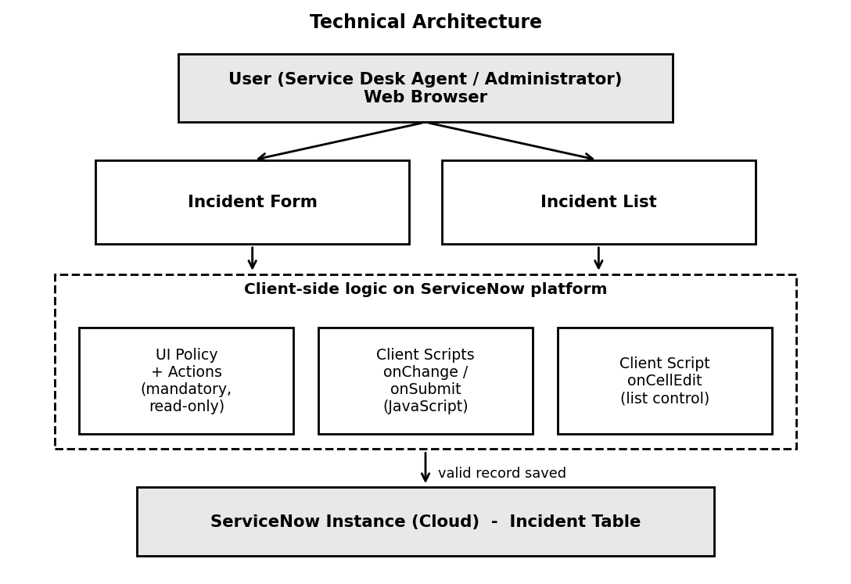
Figure 1: Architecture of the solution
4. Setup Instructions
- Prerequisites: A ServiceNow instance, administrator access to create UI Policies and Client Scripts, and a modern web browser.
- Installation: Nothing has to be cloned or installed. The configuration is created inside the instance:
1. Create the UI Policy High Impact Control on the Incident table with the condition Impact is 1 - High.
2. Add UI Policy Actions: Assignment Group mandatory, Urgency read-only; enable Reverse if false.
3. Create the onChange Client Script Auto set urgency for high impact (field: Impact).
4. Create the onSubmit Client Script Prevent save if Assigned To missing.
5. Create the onCellEdit Client Script Prevent state change via list edit (field: State).
5. Folder Structure
This is a configuration project on ServiceNow, so there is no client / server folder structure. The configuration is organized on the Incident table as follows.
- Client: UI Policy High Impact Control with two UI Policy Actions, and three Client Scripts (onChange, onSubmit, onCellEdit) on the Incident table.
- Server: ServiceNow instance (Incident table and platform services); nothing is customized on the server side.
Component | Type | Purpose
High Impact Control | UI Policy | Condition Impact is 1 - High on the Incident table
Assignment Group action | UI Policy Action | Makes Assignment Group mandatory
Urgency action | UI Policy Action | Makes Urgency read-only
Auto set urgency for high impact | Client Script (onChange) | Sets Urgency to 1 - High
Prevent save if Assigned To missing | Client Script (onSubmit) | Blocks save when Assigned To is empty
Prevent state change via list edit | Client Script (onCellEdit) | Blocks State change from the list
6. Running the Application
- Incident form: Open Incident > Create New and set the Impact to High to see the Urgency, Assignment Group and Assigned To behaviour.
- Incident list: Open Incident > All and double-click the State field of a record to check the list-edit blocking.
7. API Documentation
No custom REST endpoints are exposed. The Client Scripts use the standard ServiceNow client-side g_form API:
Script | Behaviour
Auto set urgency for high impact (onChange on Impact) | When Impact is 1 - High, Urgency is changed to 1 - High and an information message is displayed.
Prevent save if Assigned To missing (onSubmit) | When Impact is High and Assigned To is empty, an error message is displayed and the record is not saved.
Prevent state change via list edit (onCellEdit on State) | When State is edited from the list, an alert is displayed and the change is cancelled.
8. Authentication
Users log in to the ServiceNow instance with their own accounts. Administrator access is required to create the UI Policy and Client Scripts. Once configured, the same rules apply to all users working on the Incident table.
9. User Interface
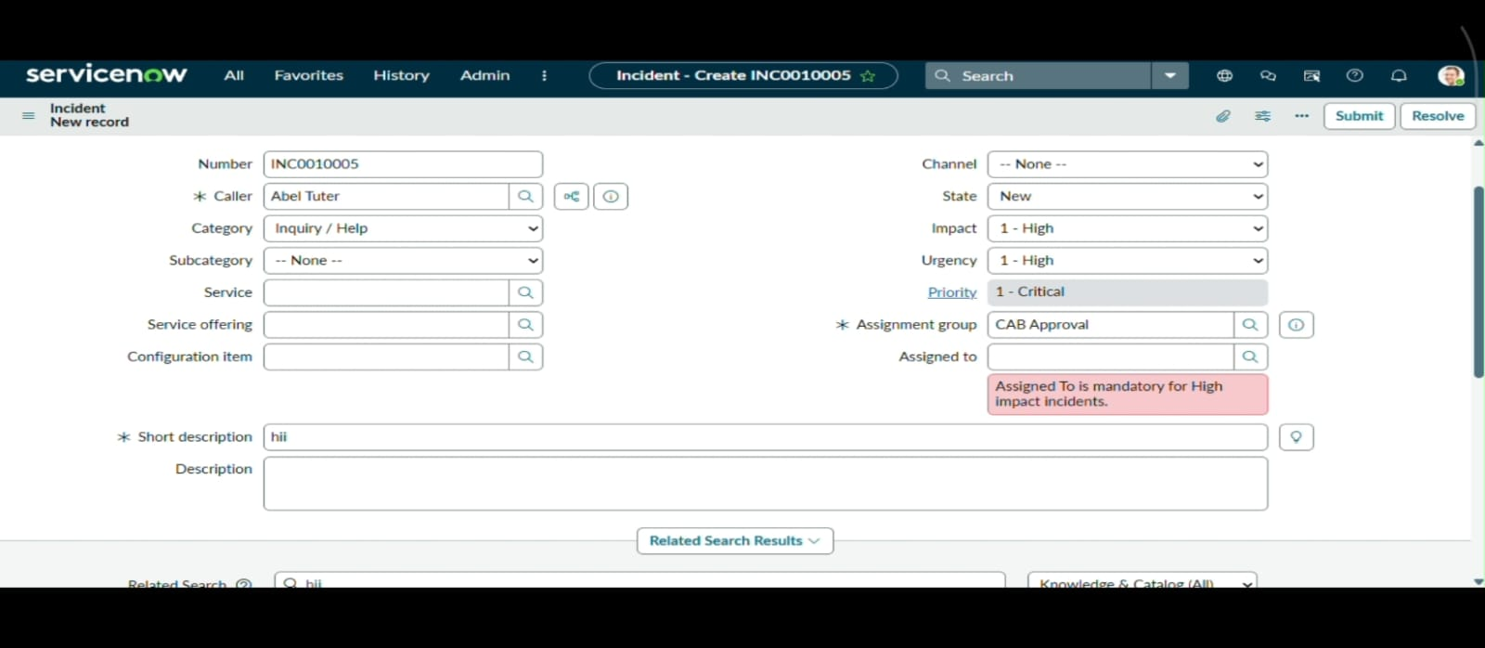
Error message when Assigned To is empty for a High Impact Incident
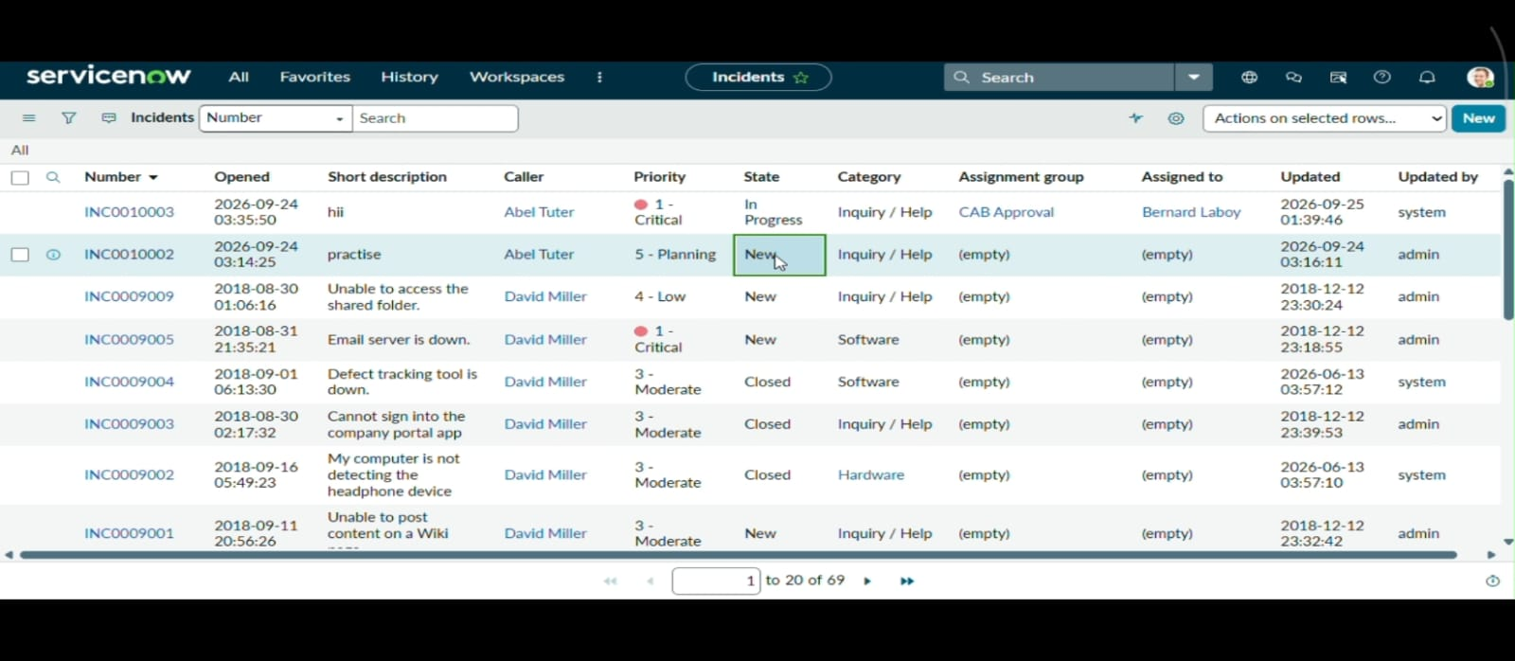
Alert when State is edited from the Incident list
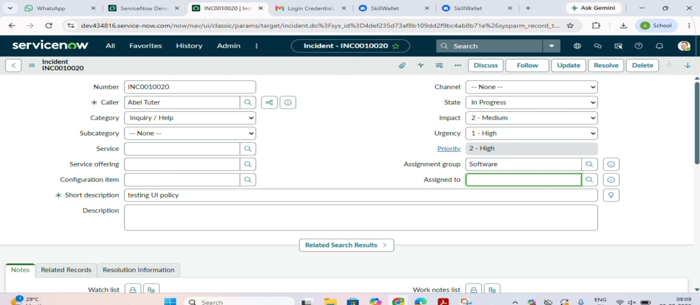
Fields become normal when Impact is changed from High to Medium
10. Testing
The project was tested manually in the ServiceNow instance with different Incident conditions: High Impact, missing Assigned To, list editing, and form-based updating. All six test cases passed.
Test Case | Expected Result | Status
High Impact with Assigned To empty | Incident should not be saved | Passed
High Impact with Assigned To filled | Incident should save successfully | Passed
Impact changed from High to Medium | Previous restrictions should be removed | Passed
State changed from Incident list | State change should be blocked | Passed
State changed from Incident form | State change should be saved | Passed
Impact changed to High | Urgency should be set to High | Passed
11. Screenshots or Demo
Screenshots of the configuration are given below. The GitHub and demo links are:
Item | Link
GitHub Project Link | https://github.com/anirosita-m/Implement-Client-Script-UI-Policy---Incident-ServiceNow-
Project Demo Link | https://drive.google.com/file/d/120MGLkj8_Jj_Z8GnTAFwjECGm7_3bgVb/view?usp=sharing
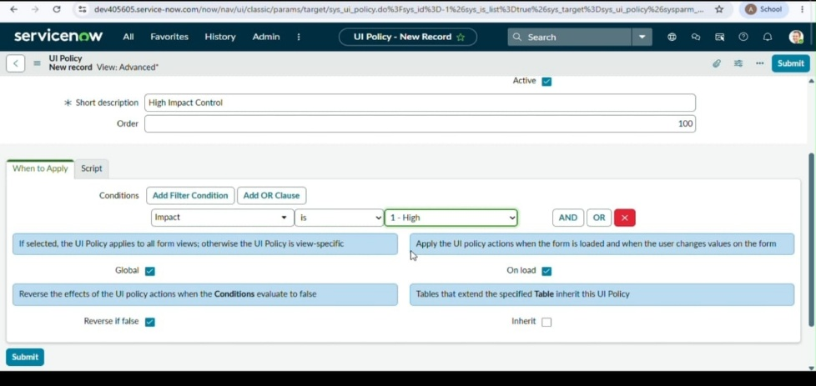
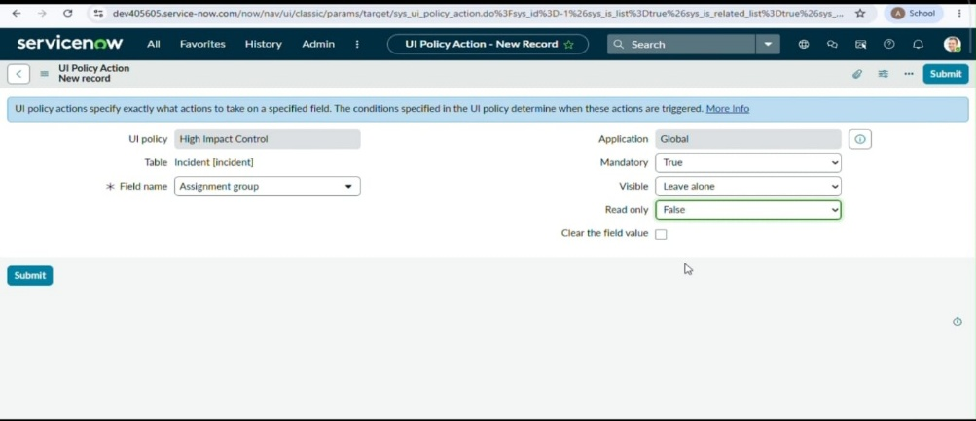
UI Policy: High Impact Control and its Assignment Group action
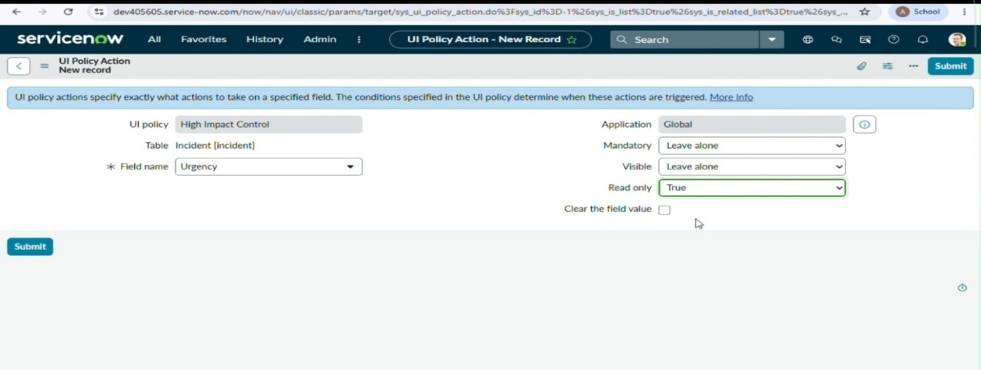
UI Policy Action: Urgency read-only
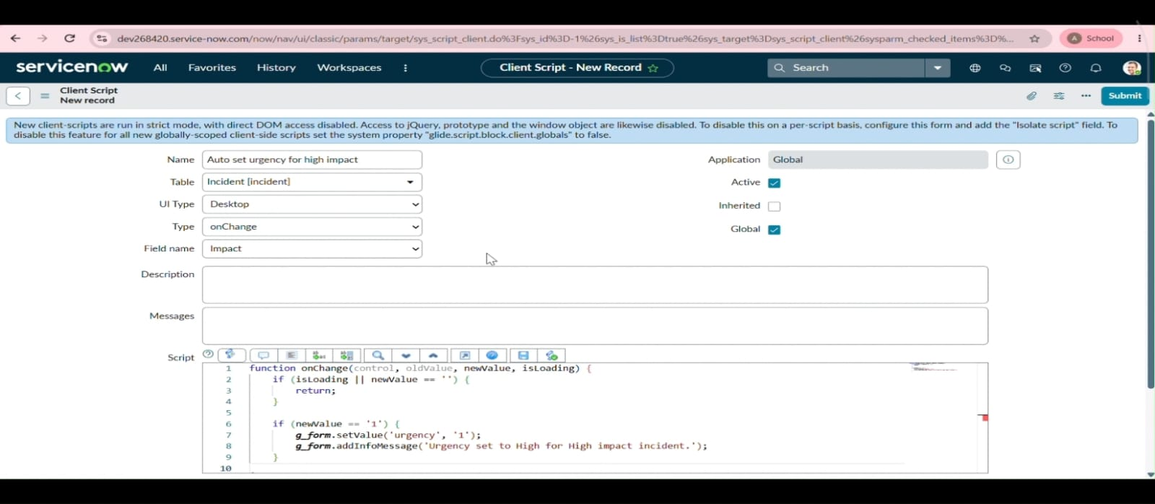
Client Script: Auto set urgency for high impact (onChange)
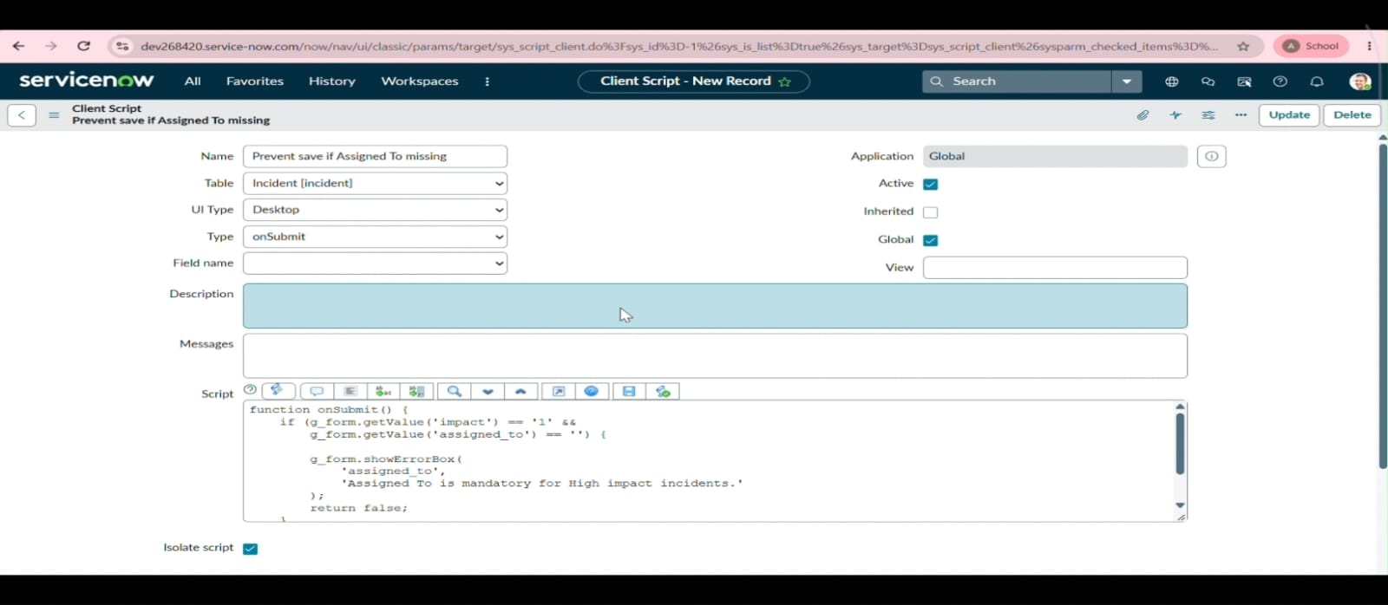
Client Script: Prevent save if Assigned To missing (onSubmit)
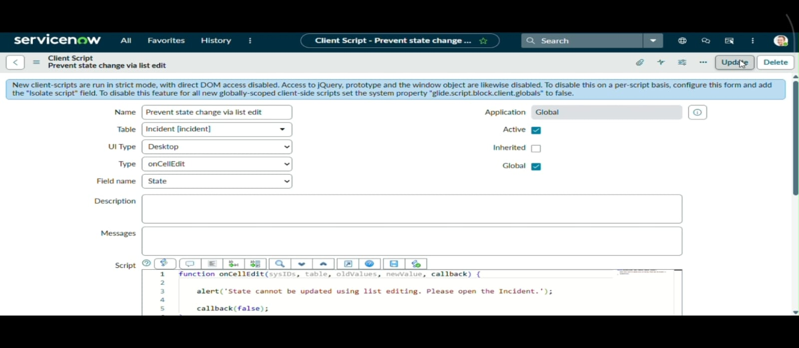
Client Script: Prevent state change via list edit (onCellEdit)
12. Known Issues
The project is limited to the Incident table only. The rules are based on a single condition, Impact being High, and do not cover other combinations such as Priority or Category. Client-side controls run in the browser and do not replace server-side rules for records changed by other means.
13. Future Enhancements
- Extend the same approach to other tables such as Problem and Change Request.
- Add more conditions based on Priority, Category, or Assignment Group.
- Integrate notifications or approvals so that High Impact Incidents are escalated automatically.

